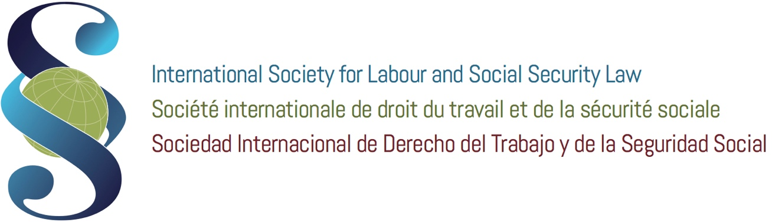

4th International Seminar on International and Comparative Labour Law, Cà Foscari University
Venice 18-24 June 2017

ISLSSL YOUNG LEGAL SCHOLARS’ SECTION
CALL FOR PAPER
TO THE NATIONAL ASSOCIATIONS OF
THE INTERNATIONAL SOCIETY FOR LABOUR AND SOCIAL SECURITY LAW

9th May 2017

Dear colleagues,

As announced in the ISLSSL Bulletin No. 145, the 4th International Seminar on International and Comparative Labour Law will take place in Venice, Cà Foscari Univerity on 18-24 June 2017.

The 2017 edition of the Seminar will be dedicated to the issue of Global Trade and Social Rights.

All Seminar’s participants are invited to take an active part in the discussion from an interdisciplinary perspective.

In particular, on Friday, 23rd June a session will be dedicated to the presentation and discussion of the papers presented by the Young Legal Scholars of the ISLSSL.

This call for paper is open to all Young Scholars who would like to take part in the International Seminar. The main topics are: Global Trade after Brexit and New Protectionism; Free trade or fair trade?; Social clause: models and experiences; International organizations, Multinationals and social conditionality.

Of course, the interested scholars can also submit additional perspectives of analysis, but always linked to the general theme of the Seminar.

INFO FOR YOUNG SCHOLARS FOR SUBMISSION OF THE ABSTRACT

This call for paper/participation is aimed to all the Labour Law Scholars who meet the requirements provided by their respective national associations to be considered as Young Scholars. They could submit their abstract (no more than 1.800 characters, including spaces, with concise title) by May 31, 2017: and the abstract have to be sent to both addresses stefanobellomo@mmba.it and islsslseminar@gmail.com .

The abstract’s paper will be examined by the Seminar’s organizers and if accepted the full paper (no more than 30.000 characters, including spaces, footnotes and appendix) has to be presented at the Session of 23rd June 2017.

PARTICIPATION IN THE WHOLE SEMINAR OR ONLY IN THE SESSION of 23rd OF JUNE

The Young Scholars have the option to choose to attend the whole Seminar (and in this case they could ask to their National Association to submit their candidature for a scholarship), please refer to the complete program and conditions of participation at the web address http://islssl.org/4th-seminar-on-international-and-comparative-labour-law-final-program/ ; or to attend only the Session of Friday, 23rd of June where the paper should be presented.
The Seminar organizers will provide for the Young Scholars who will participate only in the session of 23 June, accommodation in Colleges or residences which are connected to the Cà Foscari University for the nights of 22 and 23 June. Information about accommodation will be soson provide to the participants. The Young Scholars attending the session of Friday 23 June will also be invited to participate in the final session of the Seminar in the morning of Saturday 24th of June.
For any further information please contact Prof. Stefano Bellomo (stefanobellomo@mmba.it) or write an email to islsslseminar@gmail.com.

Best regards.

